**GRAPH THEORY**

**Types**

1. Directed graph: One way street.
2. Undirected graph: Two-way Street.

**Neighbour nodes:** They are nodes which accessible by a node through an edge by obeying the direction of an edge.

**Code**

* Adjacency list:

adjacency list

{

    a: [b, c],

    b: [d],

    c: [e],

    d: [],

    e: [b],

    f: [d]

}

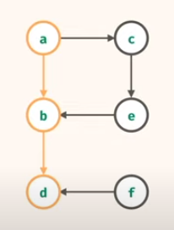

**Traversal**

* Depth first search: a, b, d, c, e,
* Breadth first search: a, b, c, d, e,

**Depth first search**

* It uses a stack.

Algorithm Pseudo code

1. Push the starting node onto the stack.
2. Pop node from the stack and immediately look at its neighbor’s and push onto the stack.
3. If the stack has elements, pop the element and push its neighbor’s onto the stack.
4. Repeat step 3 until the stack is empty.

**Important note:** We use array of JavaScript as stack and uses push and pop method.

**Breadth first search**

* It uses a queue.

Algorithm Pseudo code

1. Initialize the queue with starting node.
2. Remove the node from the queue and insert its neighbor’s elements.
3. If the queue has elements, remove the front of queue and insert its neighbor elements into the queue.
4. Repeat step 3 until the queue becomes empty.

**Important note:** array.shift is used as dequeue and array.push is used as enqueue.

**Problems**

1. Has Paths

{

f: [g, I ],

g: [h],

h: [],

i: [g, k],

j: [ I ],

k: []

}

Visualization –

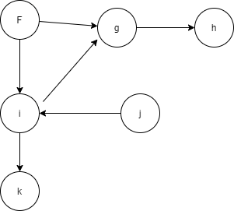

**Acyclic**

No cycles.

**Cyclic**

You end up to that node where you started, infinite loop.

**Time Complexity**

N = nodes

E = edges

Time: O(e)

Space: O(n)

1. Undirected problem: Is there a path given an undirected graph with cyclic behavior present in the graph or not present.

Edges: [

[i, j],

[k, i],

[m, k],

[k, l],

[o, n]

]

* Every pair in this edge list represents a connection between two nodes.

Converting it to adjacency list.

Adjacency list: {

i: [j, k],

j: [ i ],

k: [ i, m, l],

m: [k],

l: [k],

o: [n],

n: [o]

}

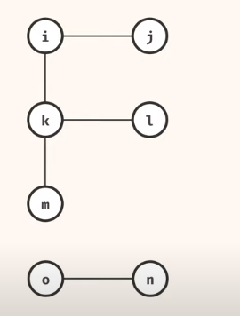

**Important note:** There may exist a cycle if a new edge exist which connects node j and node k. We have to watch out for a cycle because if we don’t do any special handling, then we may get trapped in an infinite traversal.

**Solution Algorithm:**

1. Convert edge pair to adjacency list.
2. Starting with the source node, keep a track of visited nodes list.
3. If the neighbor nodes are already visited, return false else add to visited list.
4. If all nodes are visited, end the program.

**Time Complexity**

N = nodes

E = edges

Time: O(e)

Space: O(n)

1. Connected Components count problem.

Graph: {

3: [],

4: [6],

6: [4, 5, 7, 8],

8: [6],

7: [6],

5: [6],

1: [2],

2: [1]

}

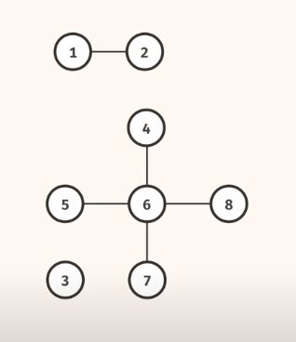

Solution: There are three components in the graph.

1. Create counter variable to store the component.

2. Iterate through every node from adjacency list.

3. Check if the node is visited or not. If it is, go to the next iteration. If the node is not visited, traverse through the current iterative node and mark the visited nodes accordingly. If there is no traversal possible, mark the counter variable with +1.

4. repeat step 2 and return the counter variable.

1. Largest Component

Graph: {

0: [8, 1, 5],

1: [0],

5: [0, 8],

8:[0,5],

2: [3,4],

3: [2, 4],

4: [3,2]

}

1. Shortest Path.

Breadth first search would be the optimum solution for shortest path because DFS goes through deeply but not look in all direction and just waste computing time.

BFS algorithm works by knowing who is going to find the node first and whoever finds the first node will be the shortest path.

1. Island count

Count the number of island present in the matrix.

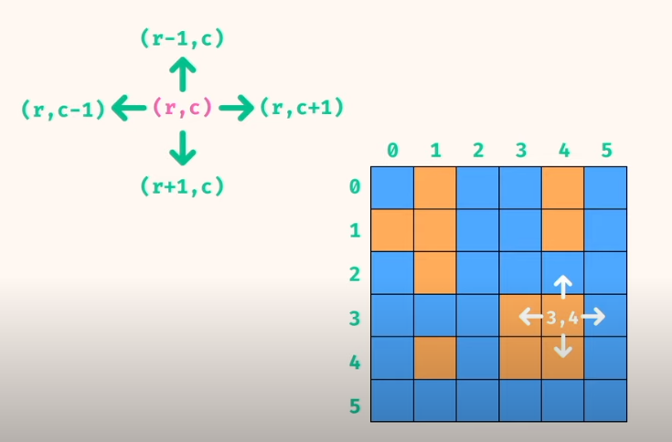

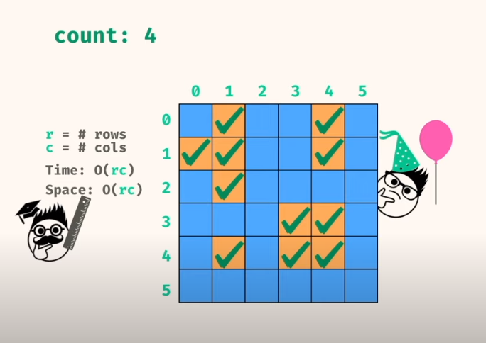

General procedure: loop through the grid and when we hit land, do a depth first traversal and mark the node as visited, when there is no more node connected, increase the count of island and continue looping from the place where we hit the land. Subsequently, when we hit a land but its already visited, ignore the node and continue iterating through the grid in top left bottom right direction.

1. Minimum island